
CoderDojo Bray
Writing games and animations with MIT Scratch

Download this doc and more examples here: http://goo.gl/zn4XC

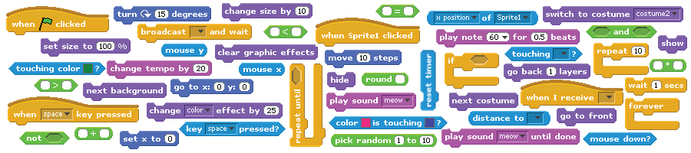

Developed by the ScratchEd team and released under a Creative Commons license.

Links

You may be interested in viewing or downloading these projects/examples.

Type | Description | Link
Video | Intro to Scratch video | http://vimeo.com/29457909
Video | Dance #1 | http://vimeo.com/28612347
Video | Dance #2 | http://vimeo.com/28612585
Video | Dance #3 | http://vimeo.com/28612800
Video | Dance #4 | http://vimeo.com/28612970
Project | About me | http://scratch.mit.edu/projects/ScratchEdTeam/2041660
Project | Dance party | http://scratch.mit.edu/projects/ScratchEdTeam/2041671
Project | Square, circle | http://scratch.mit.edu/projects/ScratchEdTeam/2042075
Project | Build-a-band | http://scratch.mit.edu/projects/ScratchEdTeam/2042276
Project | Automatic drawing | http://scratch.mit.edu/projects/ScratchEdTeam/2042282
Project | Conversation | http://scratch.mit.edu/projects/ScratchEdTeam/2042349
Project | Scenes | http://scratch.mit.edu/projects/ScratchEdTeam/2042673
Project | Slideshow | http://scratch.mit.edu/projects/ScratchEdTeam/2042695
Project | Debug it #1 | http://scratch.mit.edu/projects/ScratchEdTeam/2042697
Project | Debug it #2 | http://scratch.mit.edu/projects/ScratchEdTeam/2042703
Project | Debug it #3 | http://scratch.mit.edu/projects/ScratchEdTeam/2042706
Project | Debug it #4 | http://scratch.mit.edu/projects/ScratchEdTeam/2042712
Project | Debug it #5 | http://scratch.mit.edu/projects/ScratchEdTeam/2042724
Project | Maze | http://scratch.mit.edu/projects/ScratchEdTeam/2042736
Project | Maze Extension: Score | http://scratch.mit.edu/projects/ScratchEdTeam/2042755
Project | Maze Extension: Timer | http://scratch.mit.edu/projects/ScratchEdTeam/2042761
Project | Maze Extension: Enemies | http://scratch.mit.edu/projects/ScratchEdTeam/2042763
Project | Maze Extension: Levels | http://scratch.mit.edu/projects/ScratchEdTeam/2042764
Project | Maze Extension: Rewards | http://scratch.mit.edu/projects/ScratchEdTeam/2042770
Project | Collide | http://scratch.mit.edu/projects/ScratchEdTeam/2042778
Project | Catlibs | http://scratch.mit.edu/projects/ScratchEdTeam/2042781
Project | Scrolling | http://scratch.mit.edu/projects/ScratchEdTeam/2042861
Gallery | Sample Scratch projects | http://scratch.mit.edu/galleries/view/137903
Gallery | Sample arts projects | http://scratch.mit.edu/galleries/view/138296
Gallery | Sample stories projects | http://scratch.mit.edu/galleries/view/138297
Gallery | Sample games projects | http://scratch.mit.edu/galleries/view/138298
Gallery | Maze extensions | http://scratch.mit.edu/galleries/view/138300
Gallery | About me sample projects | http://scratch.mit.edu/galleries/view/138381
Gallery | Dance party sample projects | http://scratch.mit.edu/galleries/view/138382
Gallery | Maze sample projects | http://scratch.mit.edu/galleries/view/138299

Multi Player Games
Write a game that you can play with your friend. You can try to beat each other!

The secret here is to create one sprite for each player and give them different behaviours (movement, sensing, sound, whatever you like!).
Here's an example from our test game 'Dog eats Dog'. You can download this game from
http:/goo.gl/zn4XC from the Week 4 folder.

- As always first create a stage. We did a really cool one with a tractor beam!
Day Night
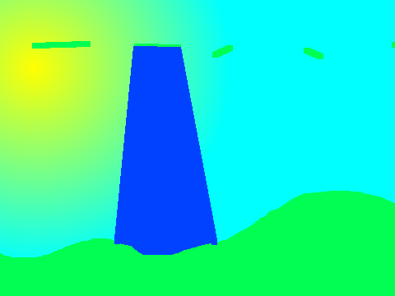
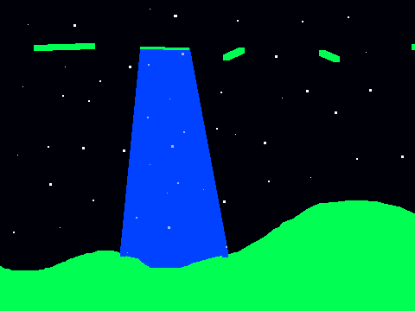
Add some scripts to switch costume between night and day and play some cool music!
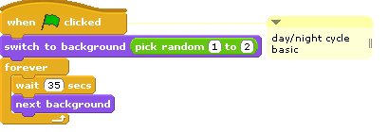
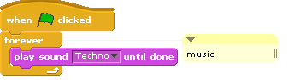
3. Now create a sprite for one of your players. Add all the scripts you need for movement. The one below even does gravity and responds to a tractor beam.

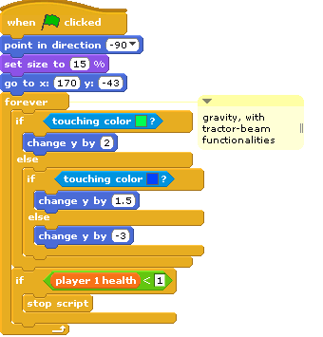 | 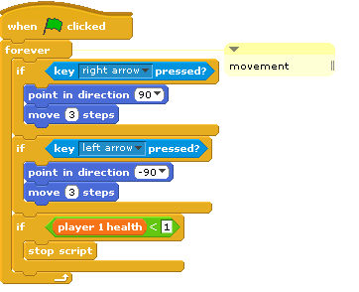

- Create another sprite for player number two. You can use the same movement scripts.
- Let's create some variables to give each player some health. That way we can tell when one player dies in the game.
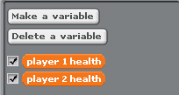

Shooting!
Here is how you can have your players shoot lasers at each other. That's generally a good way to win the game!

- Create bullet or laser sprites. Create one for each player. In our test game we created 'laser player 1' and 'laser player 2' sprites.

The lasers use the broadcast and receive functions.
 | Tells the sprite what to do when it receives a broadcast from another sprite. The laser sprite receives the broadcast.
 | Sends the 'laser 1' message to all other sprites. The player sprite sends the broadcast.

- First set up a script like the following for your player sprites so they can 'shoot' the laser.
They use the broadcast to send a signal which the laser sprite picks up. In this example you use the down arrow to shoot.

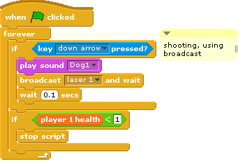
Make sure each player has different shoot and movement keys!

- Now lets add these scripts to our laser sprites so that they appear beside their player and move in the direction the player fired them.

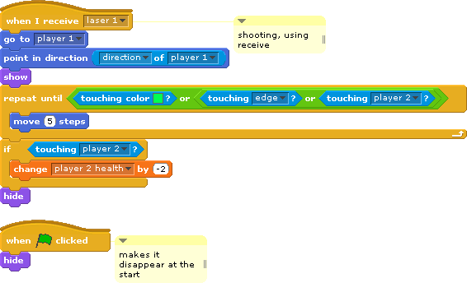

- Finally we wanted to display a message saying which player won in the end. To do this we created another sprite with two costumes
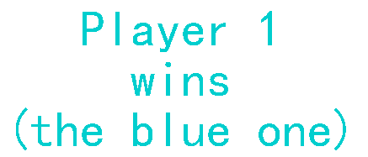 | 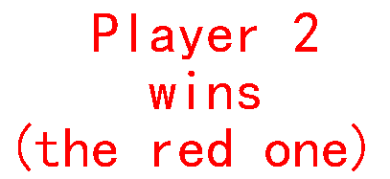
- Add the following script so that the right message displays at the end of the game.
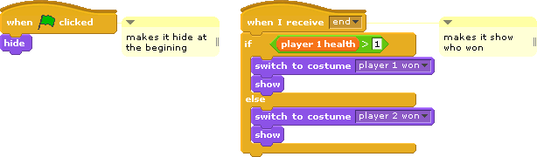
Exporting Sprites to use in your other games
Did you know you can export Sprites and use them in new games?

To export a sprite, right-click (Mac: Ctrl+click) the sprite on the Stage or in the Sprite List. Exporting saves the sprite as a .sprite file, which can then be imported into another project.

Bug #1
When I play Dog Eats Dog using the stage script below my stage keeps switching really quickly between night and day! I want it to switch much slower – maybe every 3 minutes?

